
Our Week
(Things to remember)

Children should bring their reading folders
to school on Mondays and Fridays.

New spellings are usually given out on a Monday.
Spelling tests are on a Friday.

A water bottle must be brought to school. It will stay
in school and be washed daily.

PE is on a Thursday and Friday and children should
come to school wearing PE kit.

Homework is given on a Friday each week and is to
be returned by the following Friday.

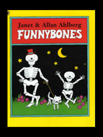

Polar Bears Class
(Year 2)
Information Leaflet

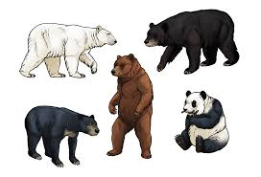
Our Theme: Bears, Bones and Toys

This term we will be:
- Reading stories and describing characters and
settings, focusing on Winnie the Witch.
- Using contents and index pages in information
books to find out about the world and countries
we have travelled from.
- Learning about healthy foods and the needs of
our bodies.
- Learning about famous people from the past,
such as Florence Nightingale and Mary Seacole.
- Learning to add and takeaway 2 digit numbers,
- Learning about the Christian beliefs on how the
Earth was created.
- Exploring the life of Henri Matisse.

Our Theme:
Our Theme: Bears, Bones and Toys

Next half term we will be:

- Writing our own version of stories, such as,
Flat Stanley
- Learning how to divide and multiply 2 digit
numbers.
- Learning how to find fractions such as ½ and ¼.
- Learning about Christmas and the nativity.
- Designing and making Christmas cards.
- Learning about toys from the past and how they
Have changed since Victorian times.
- Reading and writing our own stories.
- Reading and writing instructions.
- What life is like in the Arctic and which animals live
there.
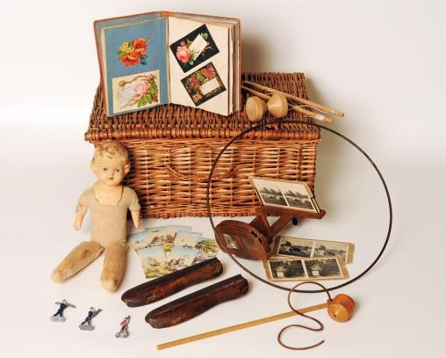


Some useful websites are:

www.bbc.co.uk/schools/scienceclips
www.phonicsplay.com
www.iboard.co.uk
www.ictgames.co.uk
https://www.bbc.co.uk/bitesize/topics/zns9nrd/articles/znsct39
https://classroom.thenational.academy/
https://www.bbc.co.uk/bitesize/levels/z3g4d2p
https://whiterosemaths.com/homelearning/
https://www.talk4writing.com/home-school-units/

Please feel free to email any member of
Y2 staff if you have any queries.

Miss Cliff
Mrs Mann
hannah.cliff@christchurch.newcastle.sch.uk
tanya.mann@christchurch.newcastle.sch.uk

