Extra Information:
Monday: Return of homework and learning logs.
Spellings given to learn.
Swimming
P.E. kit to be brought to school.
Book bag returned with evidence of reading noted in reading records. If you could either read with your child or question them about what they have read this would help greatly.
Thursday: Recorders.
Friday: Spelling test
P.E kit taken home.
Achievement assembly.

This term our project is Stones,
Bones and Dinosaurs.

This half term we will be:

- Studying Dinosaurs, the Stone Age, Bronze Age, and Iron Age on a timeline.
- Researching and finding out about different types of dinosaurs.
- Writing reports about dinosaurs.
- Researching and exploring bones and skeletons of animals, humans and dinosaurs.
- Sketching, painting and making dinosaur models.
- Learning about the role of a paleontologist.

Next half term we will be:

- Continuing to study the Stone Age, Bronze Age, and Iron Age
- Shape poetry
- The Iron Man – Ted Hughes
- Looking at rocks and soils.
- Learning about the importance of recycling.
- Finding out nutrition and a varied diet
- Guy Fawkes
- Remembrance
- Learning the recorder and performing in the Christmas production

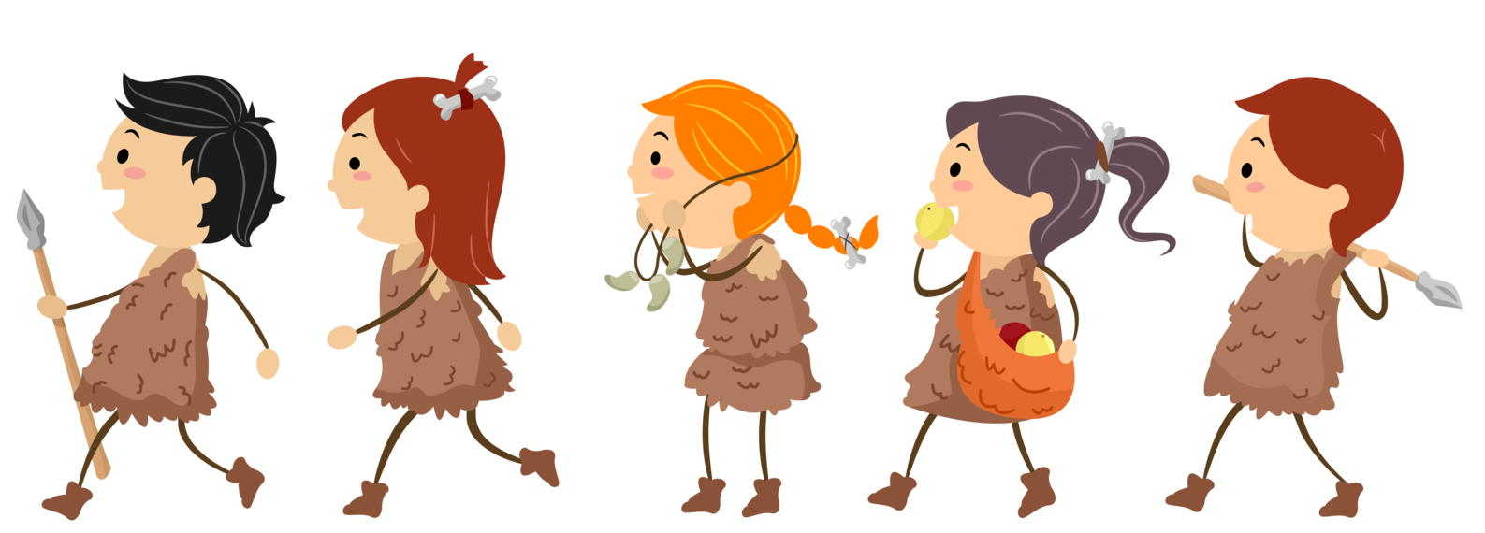
You can help by visiting the library to look at books about Britain from the Stone Age to the Iron Age.
Children could bring in any artefacts or books that are linked to the topic.

Some useful websites are:

- http://timetravellerkids.co.uk/time-travel/stone-age/
- https://www.theschoolrun.com/homework-help/the-stone-age
- https://www.dkfindout.com/uk/history/stone-age/
- http://kinooze.com/the-stone-age/
- https://www.activelearnprimary.co.uk/login?c=0

