Extra Information:
Monday:
- Spellings given out to learn for Friday;
- Homework given out to be completed by Friday;
- Bring home reading book to school.

Tuesday and Wednesday:
- PE kit.

Friday:
- Spelling test.
- Homework handed in.
- PE kit taken home.
- Class Achievement Assembly.

This term, Year 6 are Investigating and Celebrating.
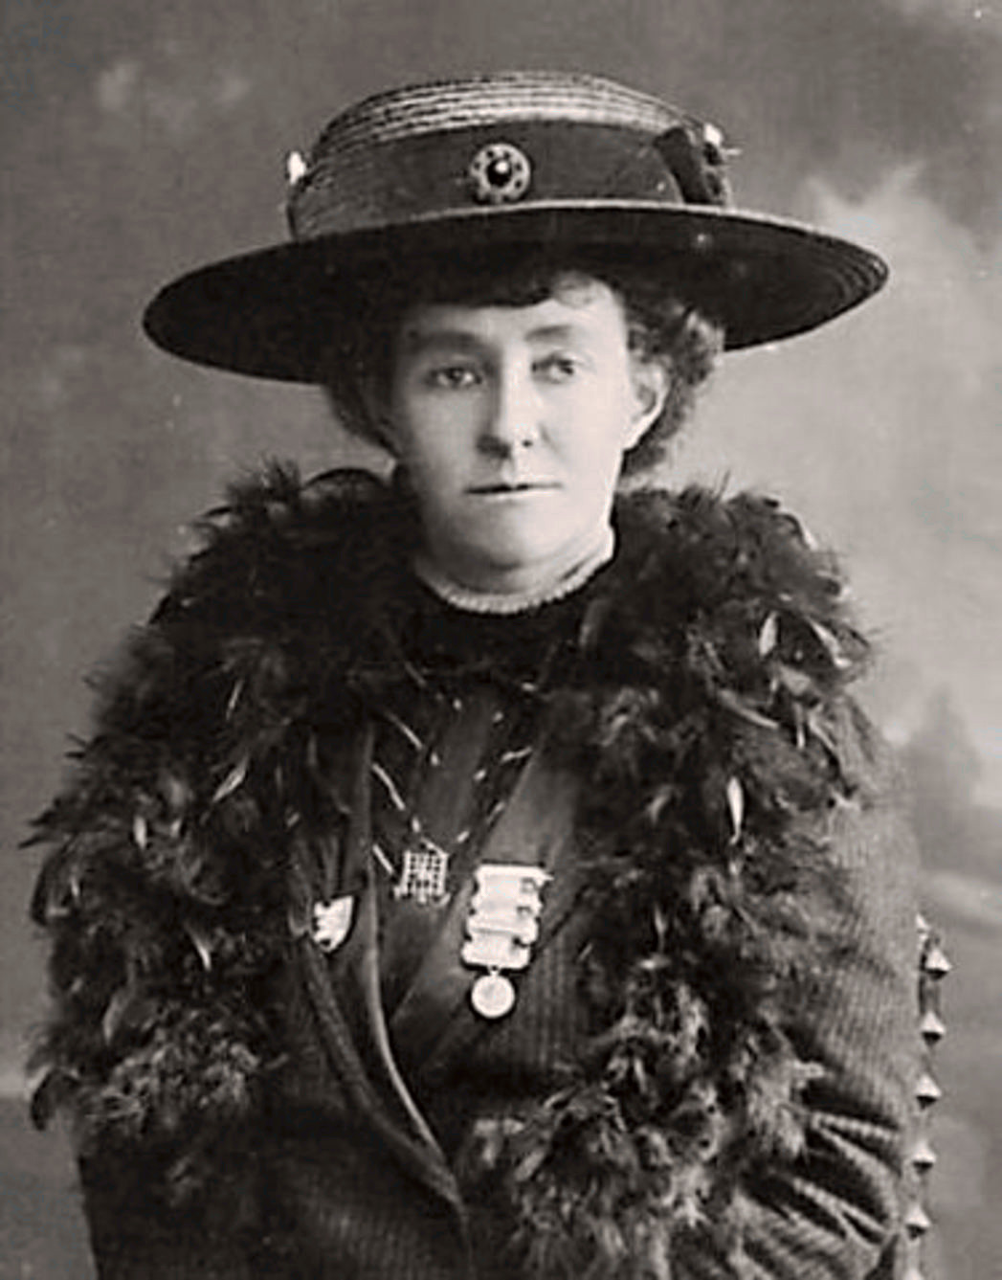
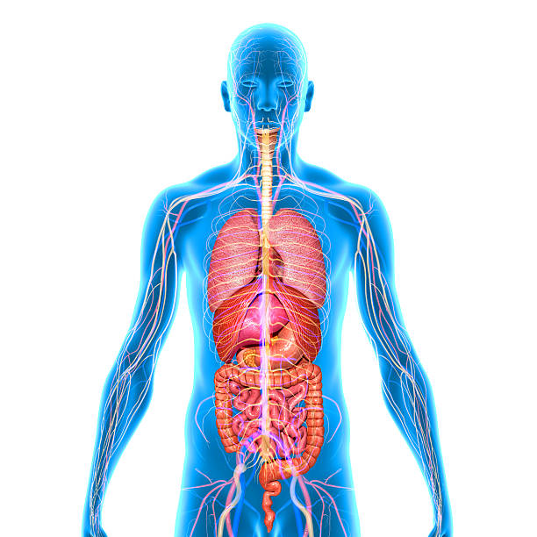
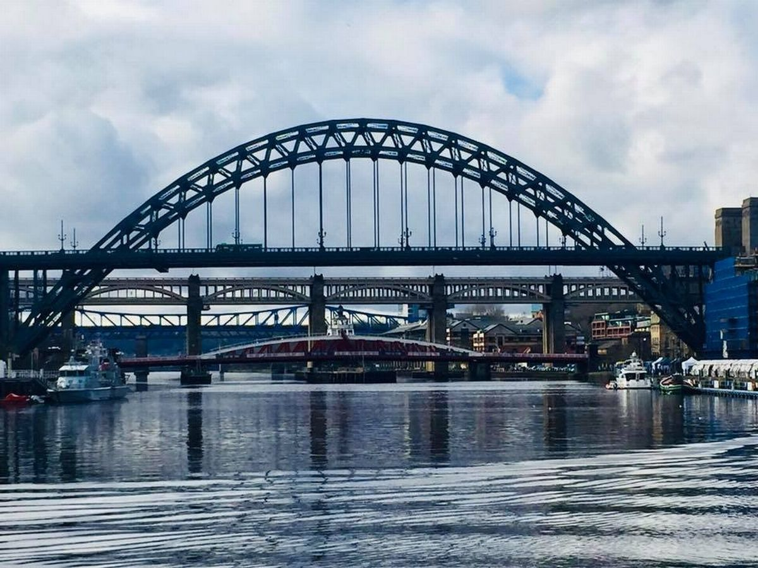

This half term we will be:

- Reading biographies and autobiographies, celebrating significant women from the last 200 years;
- Exploring the geography of the UK and looking at how the local area has changed over time;
- Investigating the death of Emily Davison and the effect she had;
- Investigating art that inspired Queen Victoria and Prince Albert;
- Investigating how the systems within our bodies keep us alive;
- Celebrating ourselves, looking to the future and investigating equality and respect in society;
- Securing our understanding of Place Value, Calculations and Multiplicative Reasoning.

Next half term, we will be:

- Investigating Victorian Britain and daily life for ordinary people;
- Reading Street Child by Berlie Doherty, The Highwayman by Alfred Noyes and Oliver Twist by Charles Dickens;
- Designing and building Victorian Fairground Rides;
- Studying the artwork of Morris, Turner and Constable;
- Investigating Darwin’s theories of Evolution and Inheritance and the impact of his book, The Origin of the Species;
- Exploring fractions, ratio, geometry and statistics.

Some useful websites are:

- http://www.woodlands-junior.kent.sch.uk/Homework/victorians.html

- http://www.channel4.com/learning/microsites/Q/qca/victorians/learningoutcomes.html

- http://www.kidshealth.org

- http://www.mathsframe.co.uk

  - https://www.mathplayground.com/grade_6_games.html

